Two ways to create local git repository

1.Git GUI

2.Git Bash

**Git GUI**

**Installation**

* **https://git-scm.com/download/win**

1.Creating goto -> windows -> search GIT GUI

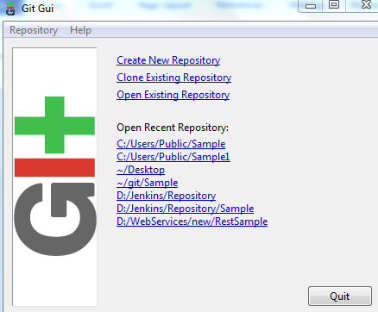

2.Select create new Repository

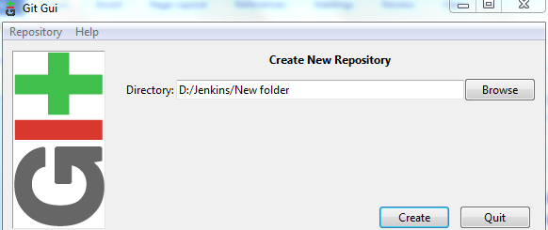

It will create new git repository and Git Gui will open for that new repository

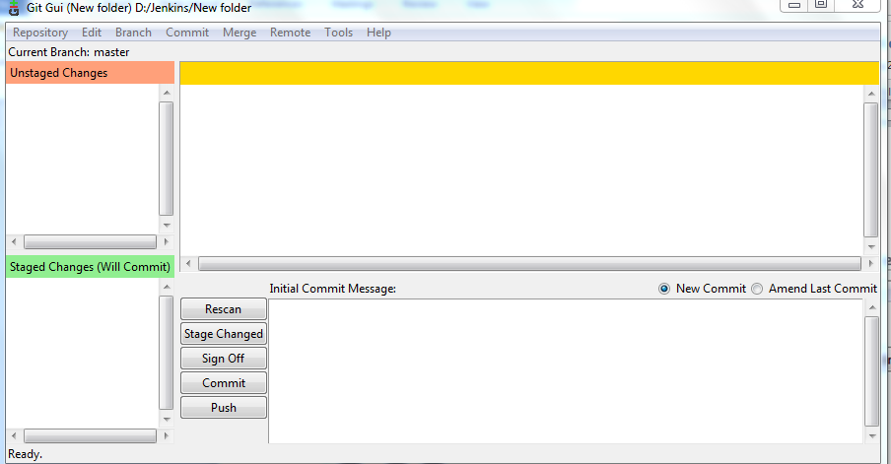

3.copy the source content to the new repository and save

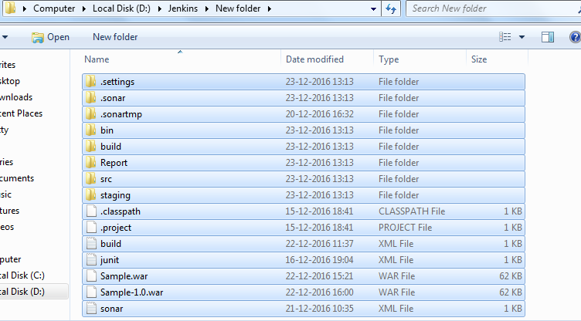

Once copied the source to the new repository ..In Git Gui all the source file will appear in the **Unstaged Changes** section

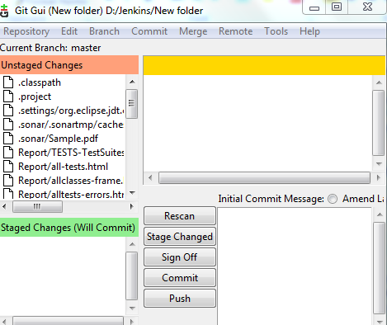

We have to click on **Stage Changed** and it comes to **staged changes** after which we have to give command as “**commit**”. code will commit at this point.

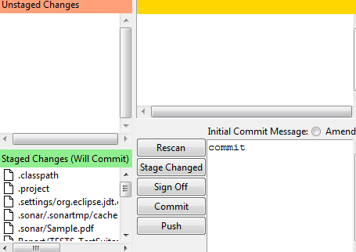

Now new master repository is ready with the source!!!

Now we have to clone the repository…..

4.In **Git Gui**

Click on **clone existing Repository** and give **Source location** and **target directory**

**Source Location-**where the master repository placed

**Target Directory-**where the cloned repository will be placed….it should also be the git repository

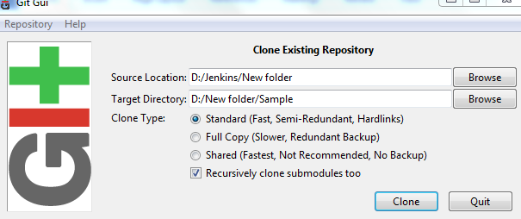

And click on **clone**

Now the source code has been cloned and the cloned repository contains all the source code content

We have to mention the cloned repository URL

D:/New folder/Sample

Another way using **Git Bash**

**Go to windows->search Git Bash**

In the Bash CMD execute following commands

1.Navigate to the folder of your choice and Create new Repository **NewRepo.git**

$git init NewRepo.git

2.Copy the source content and paste it in that folder

3.Have to add in the repository

$git add .

4.Commit the changes

$git commit –am “Save”

Now the master repository has been created which contains the source code

5.Create another repository

$git init demo.git

6.clone the repository

$git clone masterrepository clonerepository

$ git clone D:\\Jenkins\\Repository\\SampleMaster.git

D:\\Jenkins\\Repository\\demos

7.Now add source got cloned,navigate to the new repository

8.Add to the new cloned repository

$git add.

8.Commit the changes

$git commit –am “Save”

9.push into the new repository

$git push

Now the Git repository has been cloned!!!…we can use the cloned repository URL